Title : How Can You Demonstrate Linux
Setup, Command and Automation Through Practical Implementation

Course Name: B. tech (AI & ML)

Faculty: Rajesh Badrana

Assignment Number: 01

Student Name: SOUBHAGYA SAXENA

Roll Number: 2501730039

Semester: 1

Department: CS

Aim : To gain hands-on experience with Linux setup, shell commands, scripting, and GitHub for real-world automation

➢ Introduction :
Linux is a foundational operating system in the world of computer science, known for its stability, security, and open-source nature. It empowers developers and engineers to build scalable systems, automate tasks, and manage resources efficiently. This assignment aims to provide hands-on experience with Linux installation, shell command usage, and scripting for automation. By exploring real-world applications and integrating GitHub for version control, students will gain practical skills essential for careers in software development, system administration, and robotics.
TASK 1 - Linux Installation Documentation
Step 1: Open the Start menu in Windows by pressing the [Win] key or by clicking the bottom left icon of the Windows desktop

Step 2: Type “cmd”. A result similar to this will appear. Click on the Run as administrator option on the right side of the task bar.

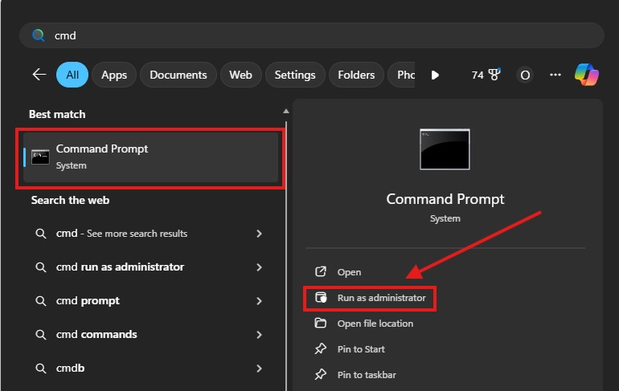

Step 3: A new window will appear similar to this.
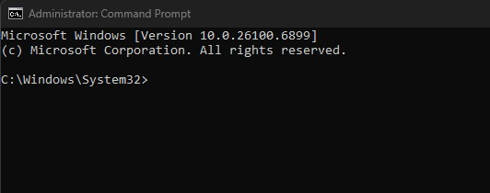
Step 4: Type the following command and press Enter to install Windows Subsystem for Linux.
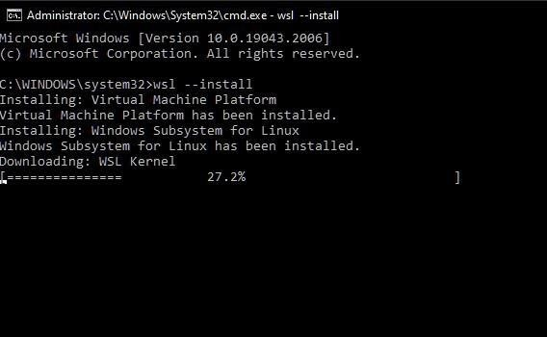

Step 5: The WSL2 installation process has begun. It will install the Linux Kernel during this process. After the process has been completed, the user gets acknowledged that Windows Subsystem for Linux (WSL) has been installed.
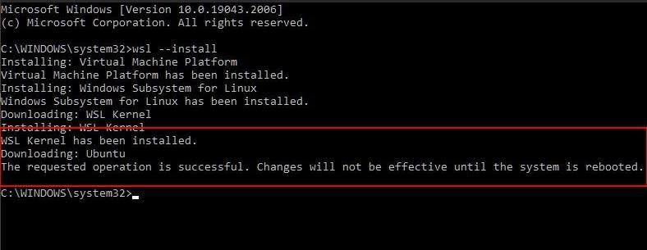
Step 6: Now WSL has been successfully installed onto your Windows Operating System. Restart your Operating System. Upon restarting you can use Windows Subsystem for Linux (WSL2).
Note: by default the Ubuntu distribution gets installed in Windows Subsystem for Linux (WSL2). If you want any specific distribution, you can get so by replacing the command wsl --install with wsl --install -d DIST
Where DIST is the name of the distribution you want to install.
The Hardware Configuration I used is as follows:
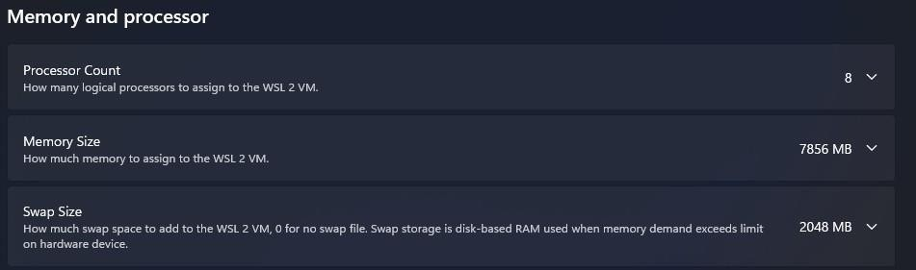
- CPU Cores Allocated: 8 Cores
- RAM Allocated: 7856 MB
- SWAP SIZE: 2048 mb (Disk space reserved for virtual memory)

TASK 2 - Shell Commands Implementation and Documentation
Command | syntax | Description | Use case /when to use
ls | ls | Lists files and directories in the current location | To view contents of a folder
cd | cd foldername | Change the  current directory | To navigate into a specific folder
pwd | pwd | Prints the current working directory path | To confirm your current location in the file  system
tree | tree | Display directory structure in tree format | To visualize folder hierarchy
mkdir | mkdir folder | creates a new  directory | to  organize file into folder

touch | touch filename | Creates a new empty file | To quickly generate a file for editing
cp | cp source | Copies files or directories | To duplicate files or backup data
mv | Mv source des | Moves or renames files/directories | To organize or rename files
rm | Rm filename | Deletes files or directories | To remove unwanted files
chmod | Chmod 755 filename | Changes file permissions | To control who can read/write/execute a file
chown | Chown user | Changes file ownership | To assign file access to specific users
ps | ps | Display active processes | To monitor running programs

top | top | Real-time view of system processes and resource usage | To analyze  CPU/memory  usage
Kill | Kill PID | Terminates a process by its ID | o stop unresponsive programs
ping | ping  website.com | Checks network connectivity to a host | To test internet or server connection
ifconfig | ifconfig | Displays network interface configuration | To view IP address and network status
Ip | Ip a | Shows IP address and network interfaces | Modern alternative to ifconfig
Netstat | Netstat-tuln | Lists active network connections and ports | To check open ports and services
 | Echo”hello” | Prints text to the terminal | To display messages or test output
cat | Cat filename | Displays file content | To read files directly in terminal

TASK 2 - Shell Commands Implementation and Documentation • pwd
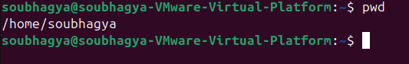
- touch
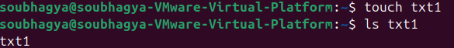
- tree
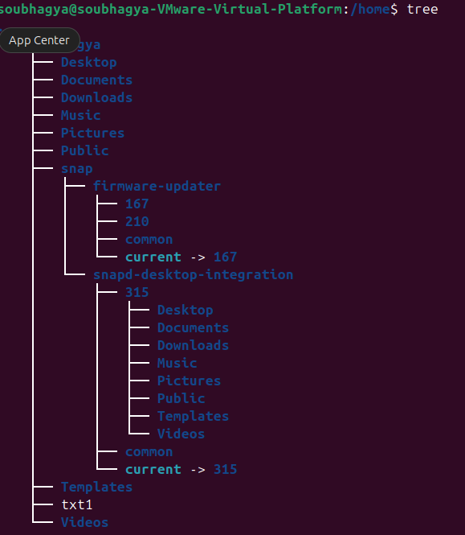

chown , ls
- chmod
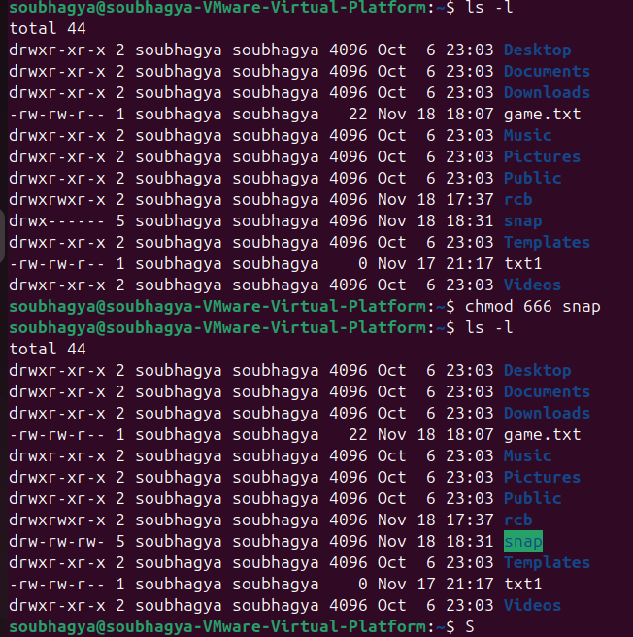
- mkdir
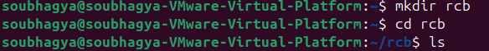
- cat
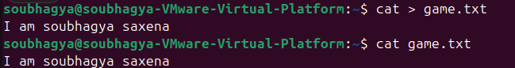

top
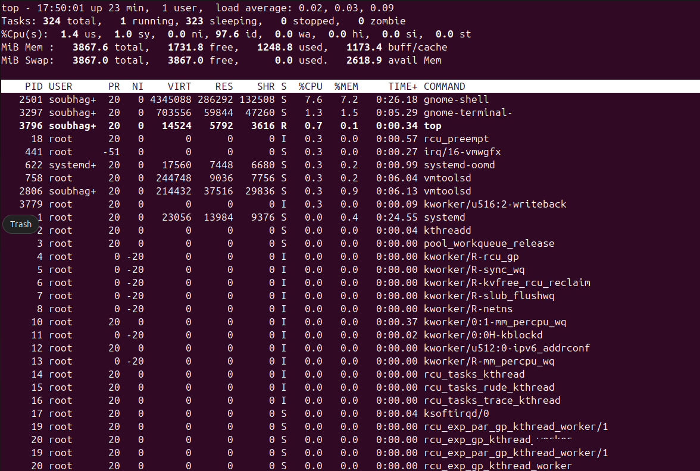
- kill
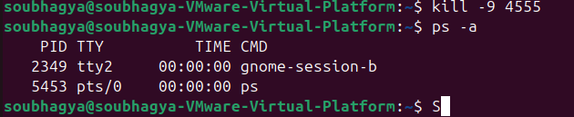

- ping
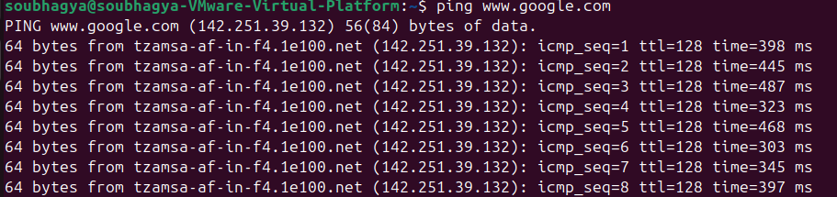
Ipeonfig/ip addr
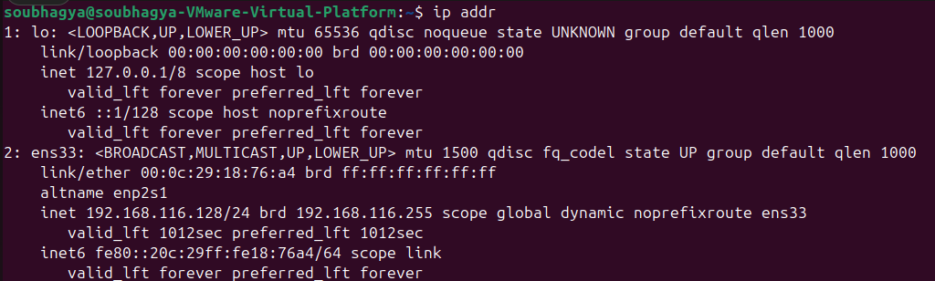
- Net-stat
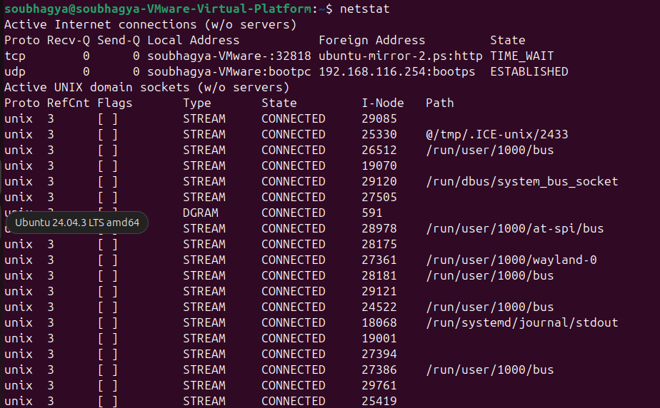

TASK -3 Shell Script Development 1.Backup a directory
Script that copies a specified directory to a backup folder with a timestamp
#!/bin/bash
# Author: Soubhagya Saxena
# Date: 14/11/2025
#--- Script to backup a directory ----
#check if target directory argument is provided. if [ -z "$1" ]; then echo "Usage: $0 <target_directory>"

exit 1 # exit with an error status of 1 , abnormal termination fi
# path of the target directory (from argument)
Tar_path= “$1”
#verify that target directory exists if [!-d “$Tar_path”]; then echo “Error: Target directory '$target_path' does not exist.” exit 1 # exit with an error status of 1 , abnormal termination fi
# path of the backup directory and logs backup_path="/home/samarth/backup/directories" log_path="/home/samarth/backup/logs"

# current date and time (for folder name and log) timestamp=$(date +"%Y-%m-%d_%H:%M:%S")
# ensure backup and log directories exist

mkdir -p "$backup_path" mkdir -p "$log_path"

# create a timestamped backup folder backup_folder="$backup_path/backup_$timestamp" mkdir "$backup_folder"

#copy the target directory recursively into the backup folder cp -r "$target_path" "$backup_folder"

# define log file log_file= “$log_path/log.txt"

# if log file doesn't exist, create it if [! -f “$log_file”]; then touch “$log_file”
fi

#write timestamp to log file echo "[$timestamp] Backup of '$target_path' completed -> $backup_folder" >> "$log_file" # print success message echo "Backup successful!" echo "Files saved in: $backup_folder"

2. CPU/Memory Monitoring

Script that logs CPU and memory usage to a file at regular intervals
#!/bin/bash
# Author: Soubhagya Saxena
# Date: 14/11/25
# --- Script to log CPU and memory usage to a file at regular intervals --- # log file path log_file_path="/home/samarth/monitoring_logs" log_file="$log_file_path/sys_monitoring.log"

# interval in seconds (default: 5) interval=5

# create log file directory if it doesn't exist mkdir -p "$log_file_path"

# create log file if it doesn’t exist if [ ! -f "$log_file" ]; then
echo "Timestamp, CPU(%), Memory(%)" > "$log_file" fi

# infinite loop to log usage while true do
timestamp=$(date +"%Y-%m-%d %H:%M:%S")

# get CPU usage (user + system) cpu_usage=$(top -bn1 | grep "Cpu(s)" | awk '{print 100 - $8}')

# get memory usage (%) mem_usage=$(free | grep Mem | awk '{print $3/$2 * 100.0}') # append to log file echo "$timestamp, $cpu_usage, $mem_usage" >> "$log_file"
# wait for the interval sleep $interval done

3. Automated Download

Script that downloads a file from the internet using wget or curl and stores it in a predefined directory.

#!/bin/bash
# Author: Soubhagya saxena
# Date: 14/11/25
# --- Script to automate downloads ---

# check if target url argument is provided if [ -z "$1" ]; then echo "Usage: $0 <target_url>" exit 1 # exit with an error status of 1 , abnormal termination fi
# Initialise the file URL with the first argument
url="$1"

# Predefined directory for downloads download_dir="/home/samarth/downloads"
# Log file
log_file="/home/samarth/downloads/dowoad_log.txt"

# Create directory if it doesn’t exist mkdir -p "$download_dir"

# Extract filename from URL filename=$(basename "$url") # Download using wget echo "Downloading $filename ..." wget -q -O "$download_dir/$filename" "$url"

# Check if download was successful
if [ $? -eq 0 ]; then
echo"Download successful: $download_dir/$filename" echo "$(date): Downloaded $filename from $url" >> "$log_file" else echo "Download failed!" echo "$(date): Failed to download from $url" >> "$log_file" fi

Task 4- Github Repository Submission
The github repository for the bash scripting task can be found here: https://github.com/samarthsharma0910/linux-shell-assignment.git

REFLECTION
This assignment was a comprehensive, hands-on introduction to the Linux operating system. Moving from theory to practice, I successfully installed Windows Subsystem for Linux (WSL) , documented 20 core shell commands , and developed three functional shell scripts to automate common tasks. This process revealed several challenges, provided significant learning opportunities, and clarified the real-world applicability of these skills.

Challenges Faced
The most significant challenge was moving from a graphical user interface (GUI) to a command-line interface (CLI). In a GUI, tasks are visual, but in the CLI, they require precise syntax.
- Understanding Permissions: A key feature was file permissions. I learned that creating a script file with touch doesn't make it a program. The system would deny execution. I had to learn to use the chmod command (chmod +x script.sh ) to add execute permissions. This was a new and critical concept.
- Complex Command Chaining: While simple commands like pwd were straightforward, the CPU/Memory monitoring script was more complex. I had to learn how to pipe (|) the output of one command (like top or free) into another (like grep and awk) to extract the exact piece of data needed. This text-parsing logic was challenging.
- Process Management: Learning about ps and kill was another hurdle. It was intimidating to think about terminating processes, and it required learning the difference between a graceful shutdown (SIGTERM) and a force-quit (SIGKILL).
Learning Outcomes
This assignment provided three major learning outcomes that align with the course goals:
- System Automation: The chief takeaway is the power of automation. The backup script , for example, automates a repetitive and crucial task. By creating a timestamped folder and logging the result, I've created a reusable tool that saves time and reduces human error
- System Monitoring: I learned not just how to run commands, but why. Using top showed me a live-updating "Task Manager," and my monitoring script took this a step further by logging CPU and memory usage over time. This is the foundation of system administration.
- Network Troubleshooting: The networking commands were the most practical. I now have a clear mental workflow for troubleshooting:
- First, I'd use ping to see if a server is reachable and if my internet is working. o Second, I'd use ip addr show to find my own local IP address.
- Finally, if I were running a server, I'd use netstat -tulpn to confirm my application is actually "listening" for connections.

Real-World Applications
These skills are directly applicable in any computer science career, especially in IT and DevOps.
- The backup script is a real-world task for any System Administrator. The next step, which I can now envision, would be scheduling this script with a cron job to run automatically every night.
- The monitoring script is a basic version of what enterprise tools do to monitor thousands of servers. This is essential for maintaining website and application health.
- The automated download script is perfect for data science or business intelligence. A real-world version could be set to run daily to download new sales reports or datasets from a web URL for processing.

Finally, the entire process, from writing the scripts to uploading them to a GitHub repository , mimics the exact workflow used by software development teams for version control and collaboration.

